Title page:

SIT323 Assignment1 Portfolio

Minghao Yu

Student Id:217199249

Contents Page:

Title Page..............................................................P1

Contents Page.......................................................P2

Introduction Page.................................................P3

Document Body....................................................P4

Running Effect......................................................P6

Appendix..............................................................P10

Introduction Page:

My assignment implements the function of demand. To speak in detail:

1. To validate files: my program can exactly validate wordlist.txt, configuration.txt, crozzle.txt and the actual crozzle as well. Especially, validating crozzle in my opinion is to using data in crozzle.txt with the configuration of the other two files to check the crozzle.
2. To build the crozzle. I used an 2-d array to store it.
3. To show the crozzle and errors. Crozzle is shown in webBrowser; Errors are shown in both webBrowser and log files.

(Even there are errors, the crozzle can still be displayed.)

How to use the program:

1. Because configuration.txt and wordlist.txt are data in crozzle.txt, I provide only one file dialog in which you need to open a crozzle.txt. If you want to change the configuration.txt or wordlist.txt, just modify the data in crozzle.txt.
2. Invalid crozzle score, from my point of view, means that if any validation(3 files and the actual crozzle) is not correct, the program will take the score as invalid. Here I show both the wrong score and invalid score information.

Document Body:

Class, and its properties:

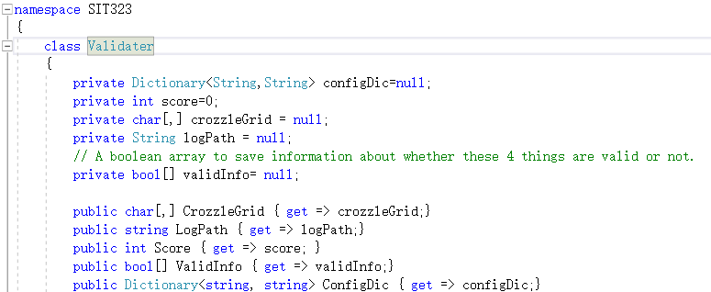

Public methods:

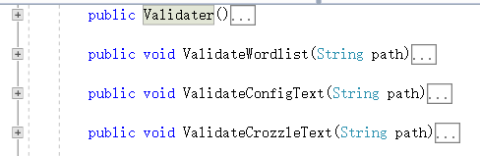

Private inner class:

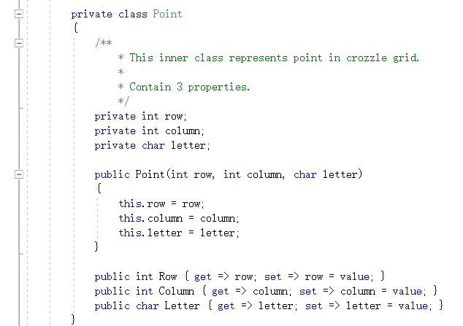

Private static method:

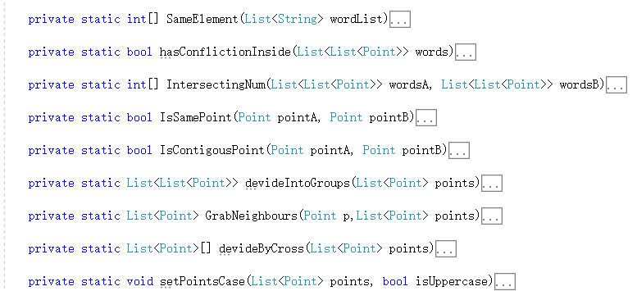

GUI designer:

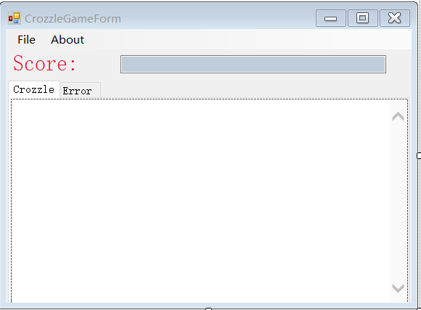

GUI logic:

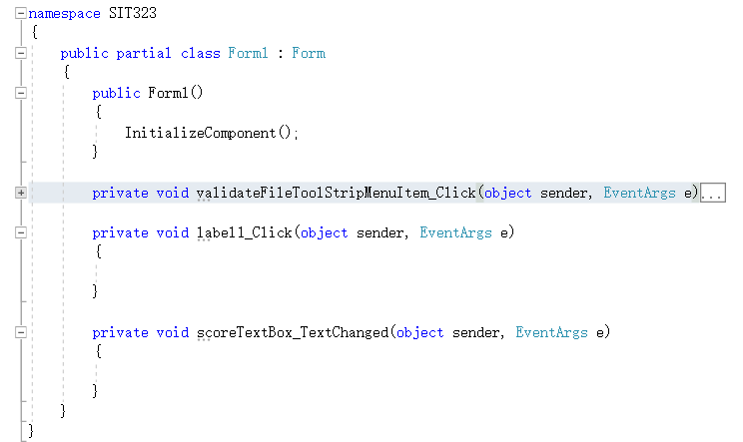

Running effect:

Marking file1:

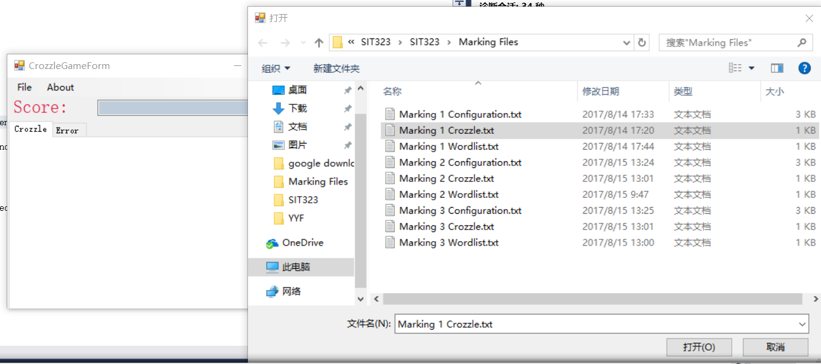

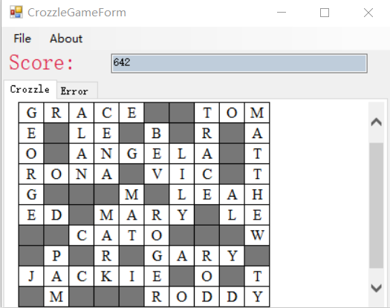

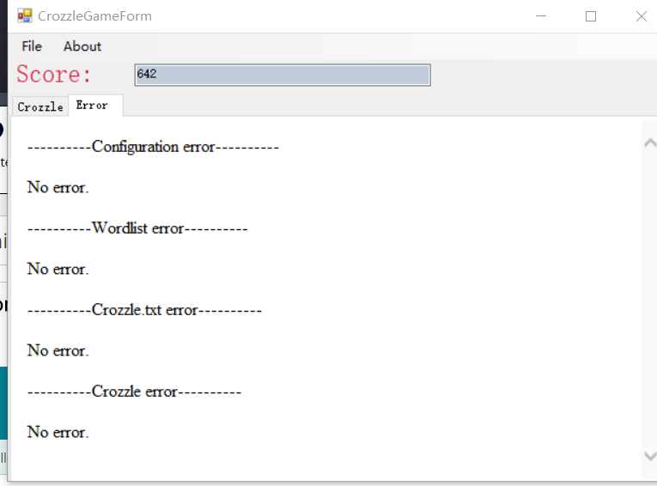

Marking file2:

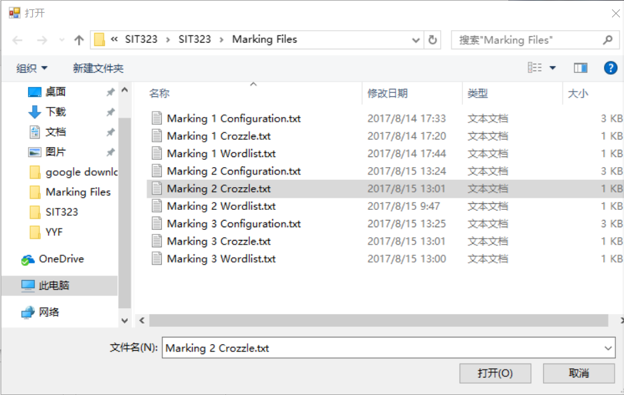

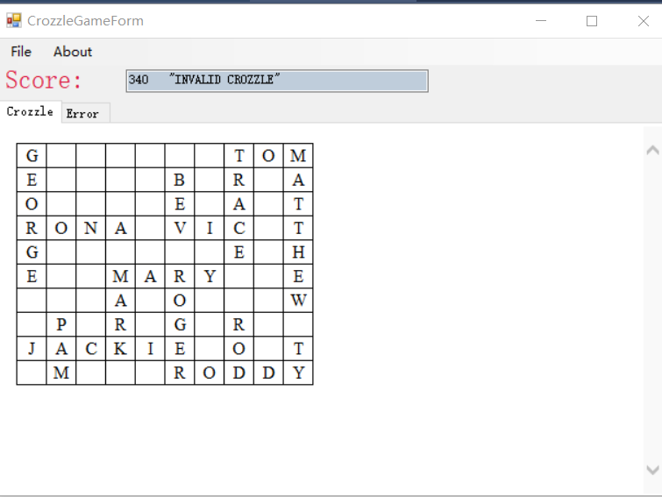

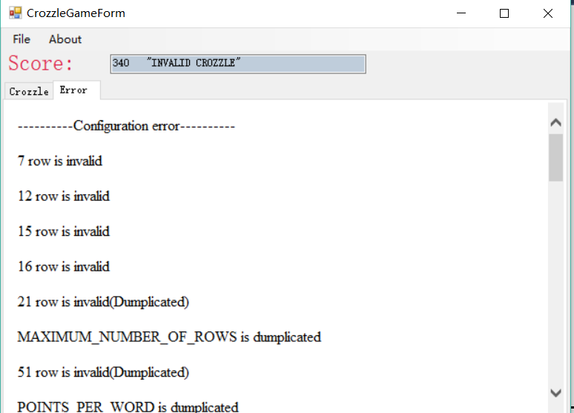

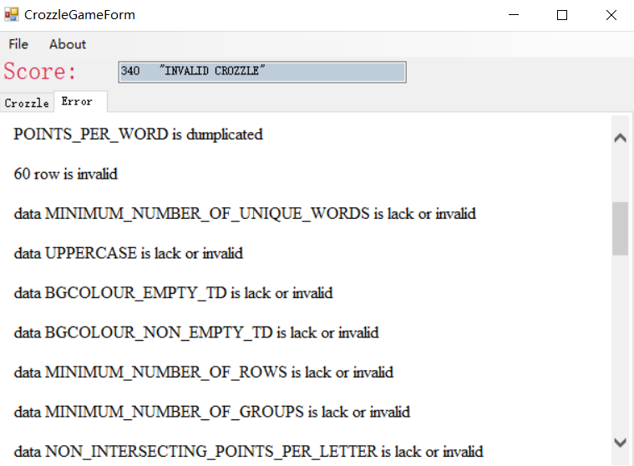

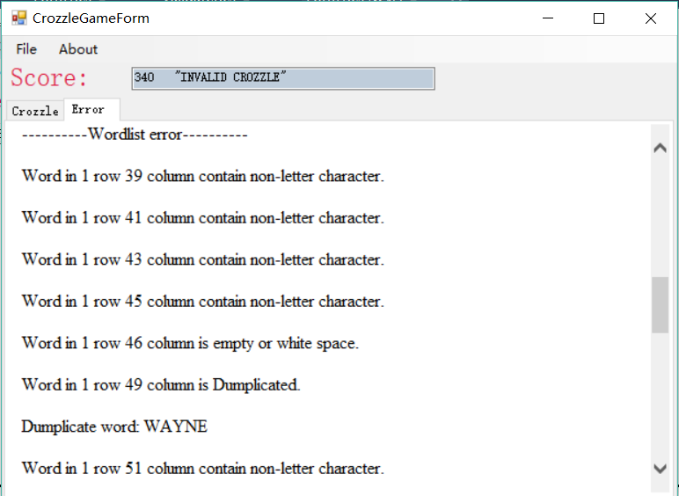

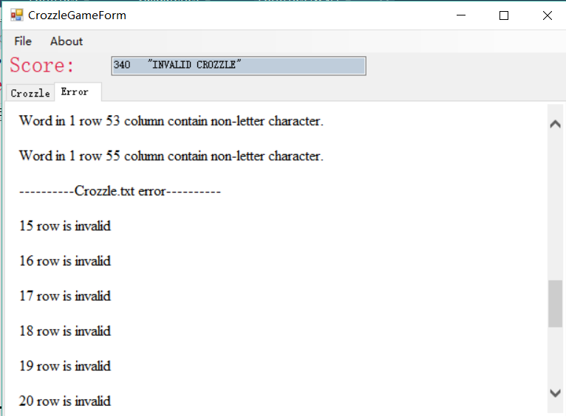

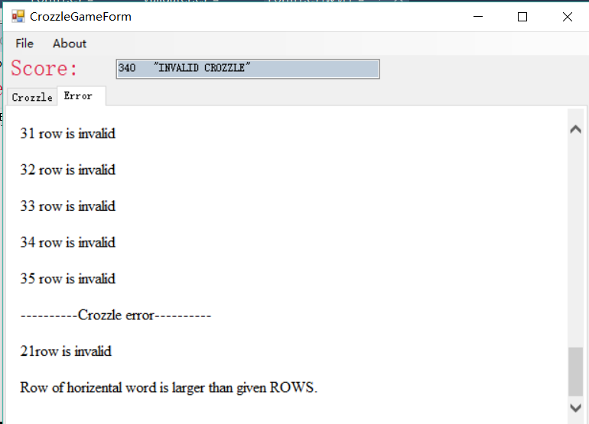

Marking file3:

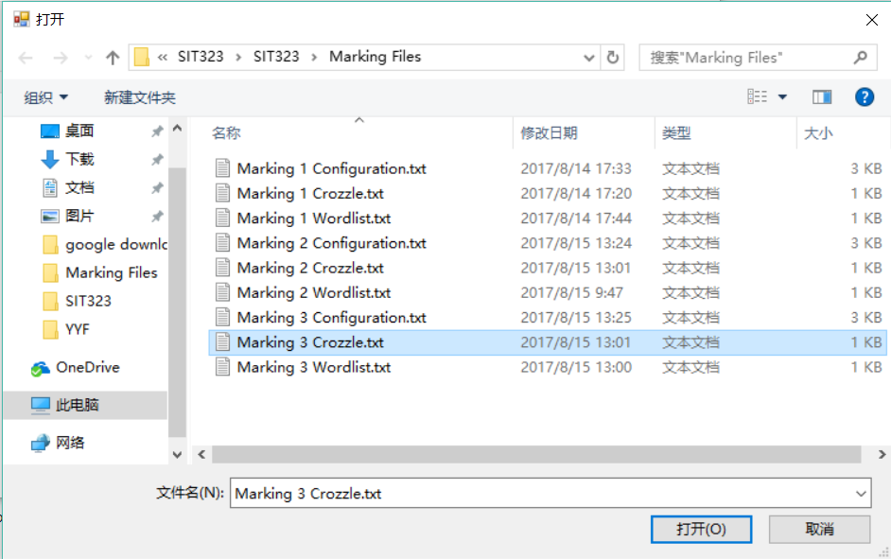

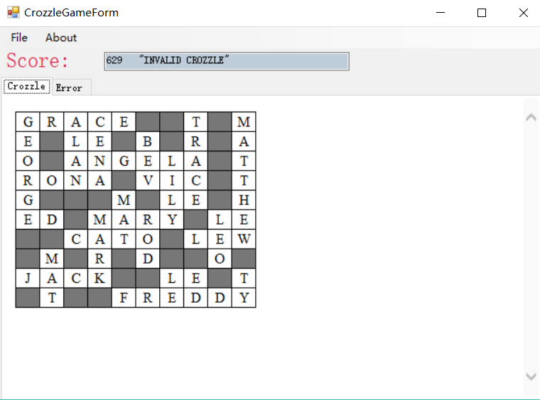

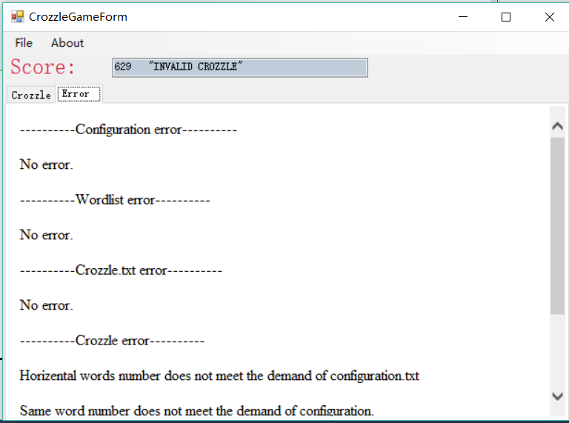

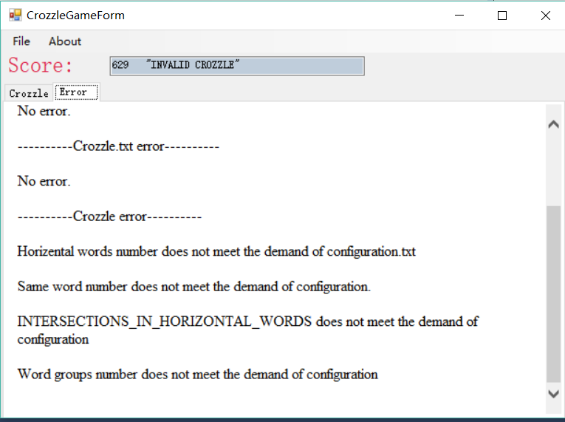

Appendix Page:

Crozzle.txt can be everywhere in computer because we use file dialog to look for it.

However, you should make sure that configuration.txt and wordlist.txt are in the same directory as crozzle.txt.

Log files must be under “File Logs” directory.